Sublime Velocity Package Installation
Velocity .vm file are a mix of HTML, CSS, and Velocity code syntax within a single file. In which to have proper syntax highlighting for all three for your developer environment, should you choose to utilize Sublime, we provide the following package for you to install.

Sublime Text Editor Installation:
You are welcome to utilize any text editor or IDE you prefer but should you not have access to those tools we recommend the Sublime text editor. Sublime is a free but powerful text editor that can be utilized for Velocity custom report development.
To install simply navigate to https://www.sublimetext.com/download and install the proper version based on your machine model.

Velocity Package Installation
Now that you’ve installed Sublime ensure you have the Java-Velocity Sublime.zip package provided alongside the Part 1 training materials downloaded to your machine.

Step 1: Extract the .zip file contents
From your downloads window extract the Java-Velocity Sublime.zip contents to your machine which should create a folder called Java-Velocity Sublime.

Step 2: Sublime Browse Packages
Now in your Sublime editor open the Browse Packages option to open the packages’ view.

Mac
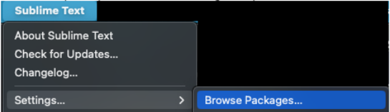

Windows:
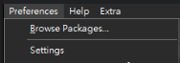

Step 3 – Add Package to Sublime
Now move your Java-Velocity Sublime folder package from your Downloads to your Packages space to install the package to Sublime.

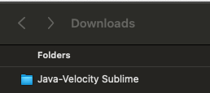
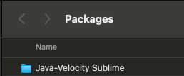

Step 4 – Utilize Package
Now anytime you open your Sublime editor with a Velocity .vm file you can adjust the editor language to utilize the Java – Velocity (HTML) option to apply syntax highlighting for both HTML/CSS and Velocity code content.
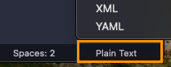

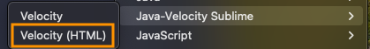

Additional Packages
Be aware that Sublime offers a variety of other packages that can help define and assist you in your development environment. You can review and install them to your Sublime editor for free using the Sublime Package Control site.

