Features
- Efficiency up to 92%
- Simple and Easy to Design Using Off-the-Shelf External Components
- 100-mΩ DMOS Output Switch
- 3.3-V, 5-V, and 12-V Fixed Output and Adjustable (1.2 V to 37 V) Versions
- 50-μA Standby Current When Switched OFF
- ±2% Maximum Output Tolerance Over Full Line and Load Conditions
- Wide Input Voltage Range: 8 V to 40 V
- External Sync Clock Capability (280 kHz to 400 kHz)
- 260-kHz Fixed Frequency Internal Oscillator
- −40°C to 125°C Operating Junction Temperature Range

Applications
- Simple to Design, High Efficiency (> 90%) Step-Down Switching Regulators
- Efficient System Preregulator for Linear Voltage Regulators
- Battery Chargers
- Communications and Radio Equipment Regulator With Synchronized Clock Frequency

Description
The LM2677 series of regulators are monolithic integrated circuits which provide all of the active functions for a step-down (buck) switching regulator capable of driving up to 5-A loads with excellent line and load regulation characteristics. High efficiency (>90%) is obtained through the use of a low on-resistance DMOS power switch. The series consists of fixed output voltages of 3.3-V, 5-V, and 12-V and an adjustable output version.
The SIMPLE SWITCHER® concept provides for a complete design using a minimum number of external components. The switching clock frequency can be provided by an internal fixed frequency oscillator (260 kHz) or from an externally provided clock in the range of 280 kHz to 400 kHz, which allows the use of physically smaller-sized components. A family of standard inductors for use with the LM2677 are available from several manufacturers to greatly simplify the design process. The external Sync clock provides direct and precise control of the output ripple frequency for consistent filtering or frequency spectrum positioning.
The LM2677 series also has built-in thermal shutdown, current-limiting, and an ON/OFF control input that can power down the regulator to a low 50-μA quiescent-current standby condition. The output voltage is ensured to a ±2% tolerance.
Table 1. Device Information
PART NUMBER | PACKAGE | BODY SIZE (NOM)
LM2677 | TO-263 (7) | 10.16 mm × 8.69 mm
LM2677 | TO-220 (7) | 10.16 mm × 8.94 mm
LM2677 | VSON (14) | 6.10 mm × 5.10 mm

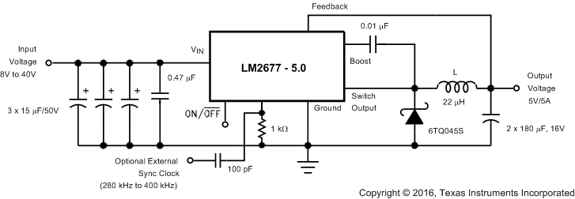
Figure 1. Typical Application
Table of Contents

1 Features 1
2 Applications 1
3 Description 1
4 Revision History 2
5 Pin Configuration and Functions 3
6 Specifications 4
6.1 Absolute Maximum Ratings 4
6.2 ESD Ratings 4
6.3 Recommended Operating Conditions 4
6.4 Thermal Information 4
6.5 Electrical Characteristics - 3.3V 5
6.6 Electrical Characteristics - 5V 5
6.7 Electrical Characteristics - 12V 5
6.8 Electrical Characteristics - Adjustable 6
6.9 Electrical Characteristics – All Output Voltage Versions 6
7 Typical Characteristics 7
8 Detailed Description 8
8.1 Overview 8
8.2 Functional Block Diagram 8
8.3 Feature Description 8
8.3.1 Switch Output 8
8.3.2 CBoost 8
8.3.3 Ground 9
8.3.4 Sync 9
8.3.5 Feedback 9
8.3.6 ON/OFF 9
8.3.7 DAP (VSON Package) 9
8.4 Device Functional Modes 9
8.4.1 Shutdown Mode 9
8.4.2 Active Mode 10
9 Applications and Implementation 11
9.1 Application Information 11
9.1.1 Inductor 11
9.1.2 Output Capacitor 11
9.1.3 Input and Output Capacitor Codes 12
9.1.4 Input Capacitor 13
9.1.5 Catch Diode 13
9.1.6 Boost Capacitor 13
9.1.7 SYNC Components 13
9.1.8 Additional Application Information 13
9.2 Typical Application 14
9.2.1 Fixed Output Voltage Applications 14
9.2.1.1 Design Requirements 14
9.2.1.2 Detailed Design Procedure 14
9.2.1.3 Application Curves 16
9.2.2 Adjustable Output Voltage Applications 17
9.2.2.1 Design Requirements 17
9.2.2.2 Detailed Design Procedure 18
9.2.2.3 Application Curve 19
10 Mechanical & Packaging 21

Revision History
Changes from I Revision (June 2012) to J Revision

- Added ESD Ratings table, Feature Description section, Device Functional Modes, Application and Implementation section, Power Supply Recommendations section, Layout section, Device and Documentation Support section, and Mechanical, Packaging, and Orderable Information section
- Deleted Manufacturers' Contact Numbers tables

Pin Configuration and Functions

KTW Package, 7-Pin TO-263
Top View
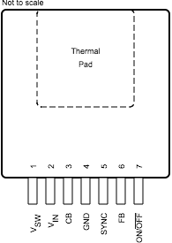
NDZ Package, 7-Pin TO-220
Top View
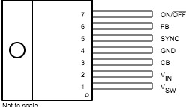

NHM Package, 14-Pin VSON
Top View
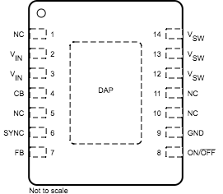
Table 2. Pin Functions
PIN |  |  | I/O | DESCRIPTION
NAME | TO-263, TO-220 | VSON | I/O | DESCRIPTION
CB | 3 | 4 | I | Boot-strap capacitor connection for high-side driver. Connect a high quality 100-nF capacitor from CB to VSW pin.
FB | 6 | 7 | I | Feedback sense input pin. Connect to the midpoint of feedback divider to set VOUT for ADJ version or connect this pin directly to the output capacitor for a fixed output version.
GND | 4 | 9 | - | Power ground pins. Connect to system ground. Ground pins of CIN and COUT. Path to CIN must be as short as possible.
NC | - | 1, 5, 10, 11 | - | No connect pins
ON/OFF | 7 | 8 | I | Enable input to the voltage regulator. High = ON and low = OFF. Pull this pin high or float to enable the regulator.
SYNC | 5 | 6 | I | This input allows control of the switching clock frequency. If left open-circuited the regulator is switched at the internal oscillator frequency, typically 260 kHz.
VIN | 2 | 2, 3 | I | Supply input pin to collector pin of high side FET. Connect to power supply and input bypass capacitors CIN. Path from VIN pin to high frequency bypass CIN and GND must be as short as possible.
VSW | 1 | 12, 13, 14 | O | Source pin of the internal High Side FET. This is a switching node. Attached this pin to an inductor and the cathode of the external diode.

Specifications

Absolute Maximum Ratings
over recommended operating junction temperature range of –40°C to 125°C (unless otherwise noted)()()
PARAMETER | TEST CONDITIONS | MIN | TYP | MAX | UNIT
Input supply voltage |  |  |  | 45 | V
ON/OFF pin voltage |  | -0.1 |  | 6 | V
Switch voltage to ground() |  | -1 |  | V_{IN} | V
Boost pin voltage |  |  |  | V_{SW} + 8 | V
Feedback pin voltage |  | -0.3 |  | 14 | V
Power dissipation |  |  | Internally Limited
Soldering temperature - Wave (4s) |  |  |  | 260 | °C
Soldering Temperature - Infrared (10s) |  |  |  | 240 | °C
Soldering temperature - Vapor Phase (75 s) |  |  |  | 219 | °C
Storage temperature, T_{stg} |  | -65 |  | 150 | °C

ESD Ratings
PARAMETER | TEST CONDITIONS | MIN | TYP | MAX | UNIT
Electrostatic discharge | Human-body model (HBM), per ANSI/ESDA/JEDEC JS-001()() |  | ±2000 |  | V

Recommended Operating Conditions
over operating free-air temperature range (unless otherwise noted)
PARAMETER | TEST CONDITIONS | MIN | TYP | MAX | UNIT
Supply voltage |  | 8 |  | 40 | V
Junction temperature |  | -40 |  | 125 | °C

Thermal Information
Table 3. Thermal Information
THERMAL METRIC() |  |  | LM2677 |  |  | UNIT
 |  |  | KTW (TO-263) | NDZ (TO-220) | NHM (VSON) | UNIT
 |  |  | 7 PINS | 7 PINS | 14 PINS | UNIT
RθJA | Junction-to-ambient thermal resistance | See() | 56 | — | — | °C/W
RθJA | Junction-to-ambient thermal resistance | See() | 35 | — | — | °C/W
RθJA | Junction-to-ambient thermal resistance | See() | 26 | — | — | °C/W
RθJA | Junction-to-ambient thermal resistance | See() | — | 65 | — | °C/W
RθJA | Junction-to-ambient thermal resistance | See() | — | 45 | — | °C/W
RθJA | Junction-to-ambient thermal resistance | See() | — | — | 55 | °C/W
RθJA | Junction-to-ambient thermal resistance | See() | — | — | 29 | °C/W
RθJC(top) | Junction-to-case (top) thermal resistance |  | 2 | 2 | — | °C/W
RθJB | Junction-to-board thermal resistance |  | — | — | — | °C/W
ψJT | Junction-to-top characterization parameter |  | — | — | — | °C/W
ψJB | Junction-to-board characterization parameter |  | — | — | — | °C/W
RθJC(bot) | Junction-to-case (bottom) thermal resistance |  | — | — | — | °C/W

Electrical Characteristics - 3.3V
T_{J} = 25°C, sync pin open circuited (unless otherwise noted). All limits are ensured at room temperature and at temperature extremes. All room temperature limits are 100% tested during production with T_{A} = T_{J} = 25°C. All limits at temperature extremes are ensured through correlation using standard standard Quality Control (SQC) methods. All limits are used to calculate Average Outgoing Quality Level (AOQL). Typical values are determined with T_{A} = T_{J} = 25°C and represent the most likely norm.
PARAMETER | TEST CONDITIONS | MIN | TYP | MAX | UNIT
Output voltage | V_{IN} = 8 V to 40 V, 100 mA ≤ I_{OUT} ≤ 5 A, T_{J} = 25°C | 3.234 | 3.3 | 3.366 | V
Output voltage | V_{IN} = 8 V to 40 V, 100 mA ≤ I_{OUT} ≤ 5 A, T_{J} = –40°C to 125°C | 3.201 |  | 3.399 | V
Efficiency | V_{IN} = 12 V, I_{LOAD} = 5 A |  | 82 |  | %

Electrical Characteristics - 5V
T_{J} = 25°C, sync pin open circuited (unless otherwise noted). All limits are ensured at room temperature and at temperature extremes. All room temperature limits are 100% tested during production with T_{A} = T_{J} = 25°C. All limits at temperature extremes are ensured through correlation using standard standard Quality Control (SQC) methods. All limits are used to calculate Average Outgoing Quality Level (AOQL). Typical values are determined with T_{A} = T_{J} = 25°C and represent the most likely norm.
PARAMETER | TEST CONDITIONS | MIN | TYP | MAX | UNIT
Output voltage | V_{IN} = 8 V to 40 V, 100 mA ≤ I_{OUT} ≤ 5 A, T_{J} = 25°C | 4.9 | 5 | 5.1 | V
Output voltage | V_{IN} = 8 V to 40 V, 100 mA ≤ I_{OUT} ≤ 5 A, T_{J} = –40°C to 125°C | 4.85 |  | 5.15 | V
Efficiency | V_{IN} = 12 V, I_{LOAD} = 5 A |  | 84 |  | %

Electrical Characteristics - 12V
T_{J} = 25°C, sync pin open circuited (unless otherwise noted). All limits are ensured at room temperature and at temperature extremes. All room temperature limits are 100% tested during production with T_{A} = T_{J} = 25°C. All limits at temperature extremes are ensured through correlation using standard standard Quality Control (SQC) methods. All limits are used to calculate Average Outgoing Quality Level (AOQL). Typical values are determined with T_{A} = T_{J} = 25°C and represent the most likely norm.
PARAMETER | TEST CONDITIONS | MIN | TYP | MAX | UNIT
Output voltage | V_{IN} = 15 V to 40 V, 100 mA ≤ I_{OUT} ≤ 5 A, T_{J} = 25°C | 11.76 | 12 | 12.24 | V
Output voltage | V_{IN} = 15 V to 40 V, 100 mA ≤ I_{OUT} ≤ 5 A, T_{J} = –40°C to 125°C | 11.64 |  | 12.36 | V
Efficiency | V_{IN} = 24 V, I_{LOAD} = 5 A |  | 92 |  | %

Electrical Characteristics - Adjustable
T_{J} = 25°C, sync pin open circuited (unless otherwise noted). All limits are ensured at room temperature and at temperature extremes. All room temperature limits are 100% tested during production with T_{A} = T_{J} = 25°C. All limits at temperature extremes are ensured through correlation using standard standard Quality Control (SQC) methods. All limits are used to calculate Average Outgoing Quality Level (AOQL). Typical values are determined with T_{A} = T_{J} = 25°C and represent the most likely norm.
PARAMETER | TEST CONDITIONS | MIN | TYP | MAX | UNIT
Output voltage | V_{IN} = 8 V to 40 V, 100 mA ≤ I_{OUT} ≤ 5 A, V_{OUT} programmed for 5V T_{J} = 25°C | 1.186 | 1.21 | 1.234 | V
Output voltage | V_{IN} = 8 V to 40 V, 100 mA ≤ I_{OUT} ≤ 5 A, V_{OUT} programmed for 5 V, T_{J} = –40°C to 125°C | 1.174 |  | 1.246 | V
Efficiency | V_{IN} = 12 V, I_{LOAD} = 5 A |  | 84 |  | %

Electrical Characteristics – All Output Voltage Versions
T_{J} = 25°C, V_{IN}= 12 V for the 3.3-V, 5-V, and Adjustable versions, V_{IN} = 24 V for the 12-V version, sync pin open circuited (unless otherwise noted). All limits are ensured at room temperature and at temperature extremes. All room temperature limits are 100% tested during production with T_{A} = T_{J} = 25°C. All limits at temperature extremes are ensured through correlation using standard standard Quality Control (SQC) methods. All limits are used to calculate Average Outgoing Quality Level (AOQL). Typical values are determined with T_{A} = T_{J} = 25°C and represent the most likely norm.
PARAMETER | TEST CONDITIONS | MIN | TYP | MAX | UNIT
Quiescent current | V_{FEEDBACK} = 8 V for 3.3-V, 5-V, and adjustable versions, V_{FEEDBACK} = 15 V for 12-V versions |  | 4.2 | 6 | mA
Standby quiescent current | ON/OFF pin = 0 V, T_{J} = 25°C |  | 50 | 100 | μA
Standby quiescent current, T_{J} = –40°C to 125°C | ON/OFF pin = 0 V |  |  | 150 | μA
Current limit | T_{J} = 25°C | 6.1 | 7 | 8.3 | A
Current limit | T_{J} = –40°C to 125°C | 5.75 |  | 8.75 | A
Output leakage current | V_{IN} = 40 V, ON/OFF pin = 0 V |  | 1 | 200 | μA
Output leakage current | V_{SWITCH} = 0 V |  |  | 15 | μA
Output leakage current | V_{SWITCH} = –1 V |  | 6 |  | mA
Switch on-resistance | I_{SWITCH} = 5 A, T_{J} = 25°C |  | 0.12 | 0.14 | Ω
Switch on-resistance | I_{SWITCH} = 5 A, T_{J} = –40°C to 125°C |  |  | 0.225 | Ω

Typical Characteristics

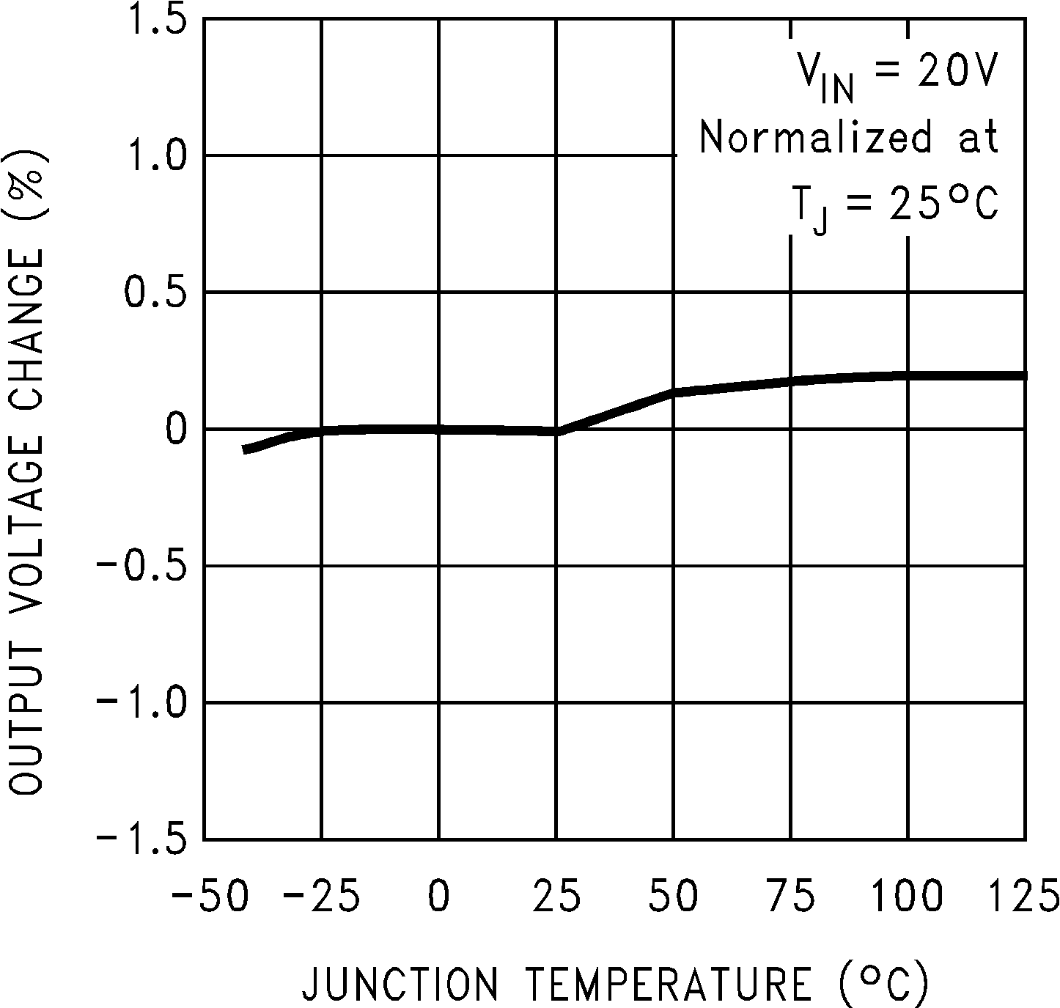
Figure 2. Normalized Output Voltage
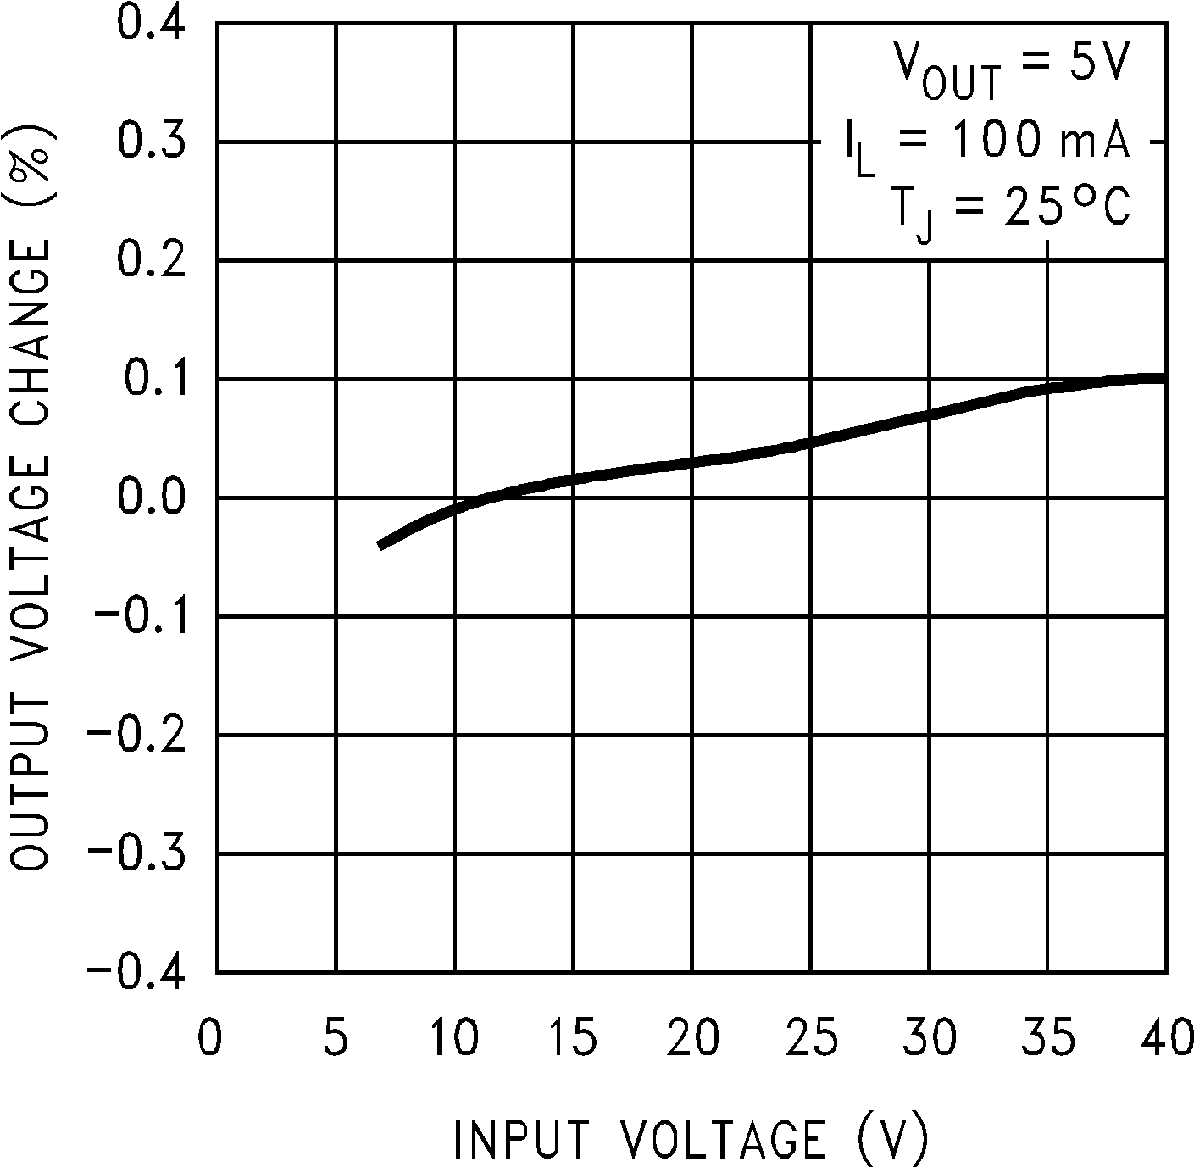
Figure 3. Line Regulation
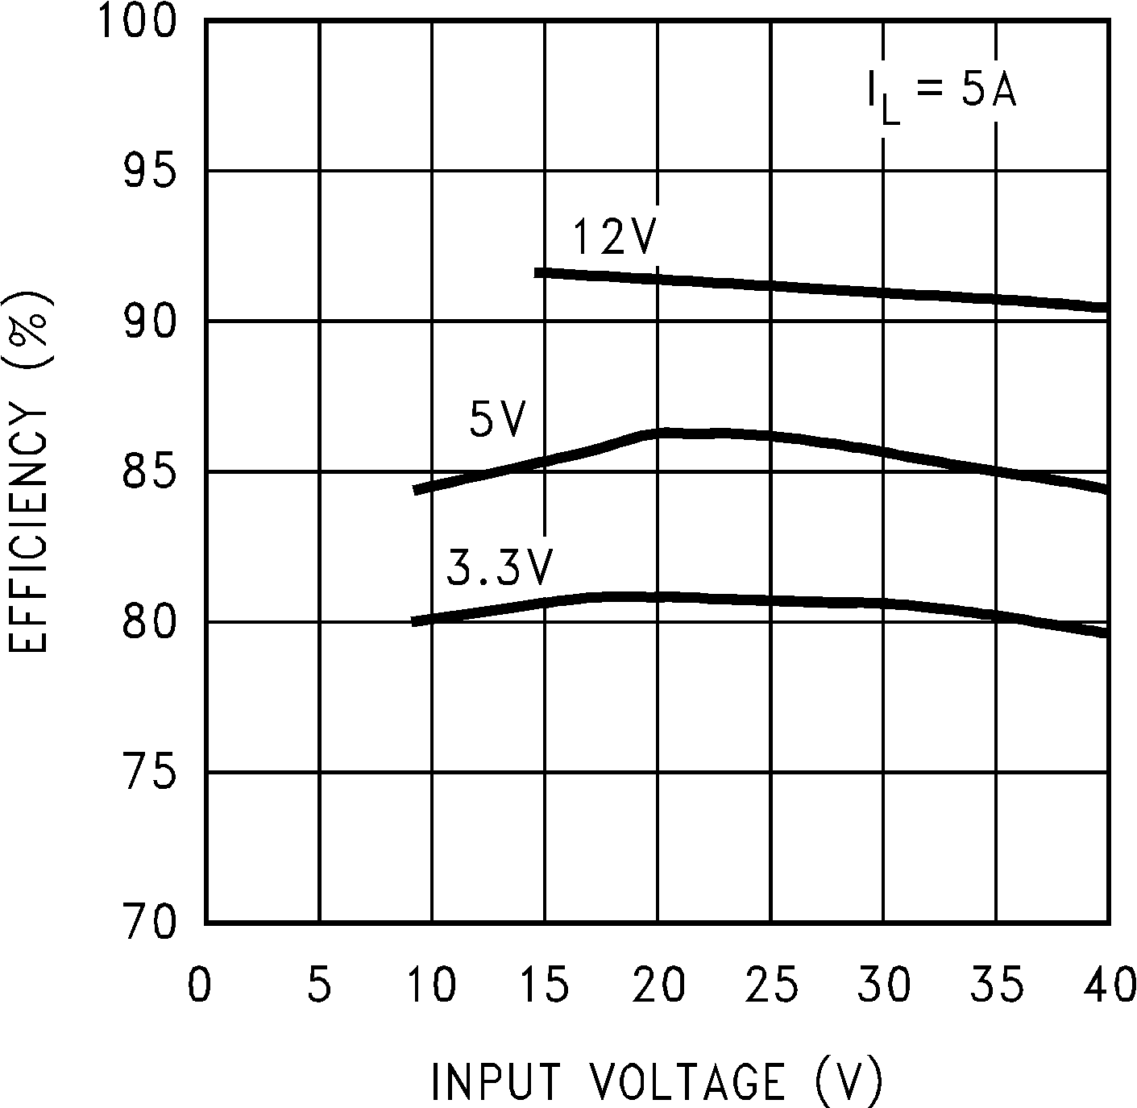
Figure 4. Efficiency vs Input Voltage
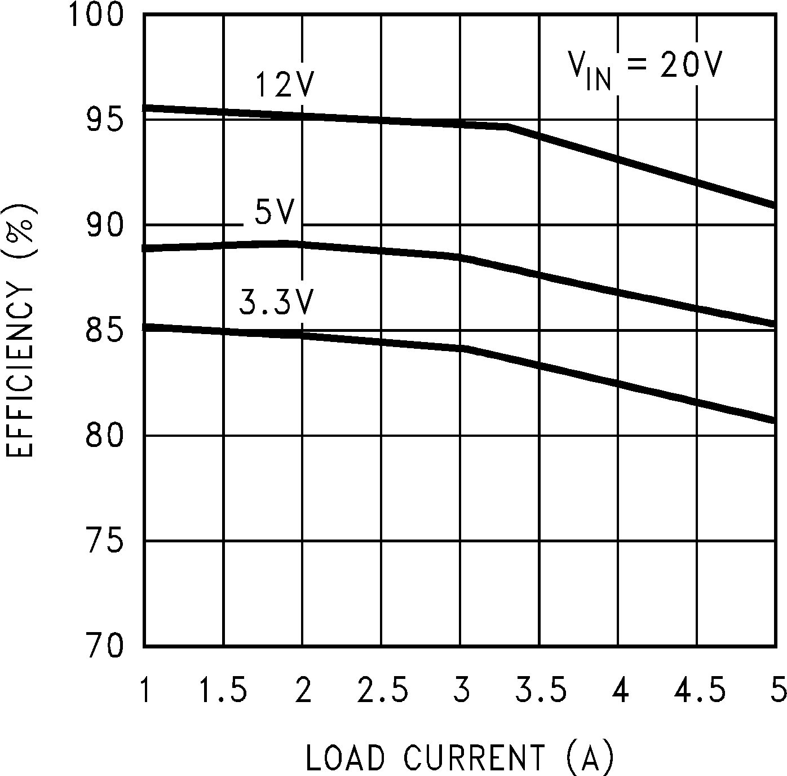
Figure 5. Efficiency vs ILOAD

Detailed Description

Overview
The LM2677 provides all of the active functions required for a step-down (buck) switching regulator. The internal power switch is a DMOS power MOSFET to provide power supply designs with high current capability, up to 5 A, and highly efficient operation.
The LM2677 is part of the SIMPLE SWITCHER family of power converters. A complete design uses a minimum number of external components, which have been predetermined from a variety of manufacturers.

Functional Block Diagram
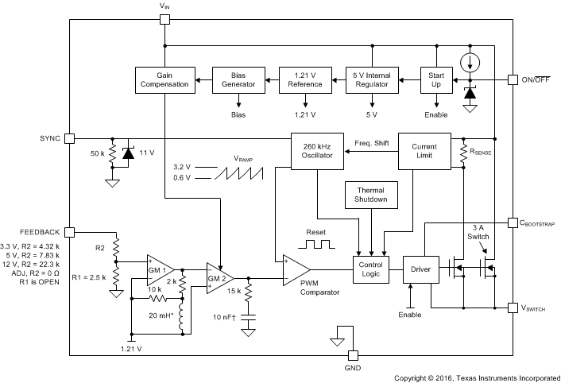
Figure 6. Functional Block Diagram

Feature Description

Switch Output

This is the output of a power MOSFET switch connected directly to the input voltage. The switch provides energy to an inductor, an output capacitor, and the load circuitry under control of an internal pulse-width-modulator (PWM). The PWM controller is internally clocked by a fixed 260-kHz oscillator. In a standard step-down application the duty cycle (Time ON/Time OFF) of the power switch is proportional to the ratio of the power supply output voltage to the input voltage. The voltage on pin 1 switches between V_{IN} (switch ON) and below ground by the voltage drop of the external Schottky diode (switch OFF).

CBoost
A capacitor must be connected from pin 3 to the switch output, pin 1. This capacitor boosts the gate driver to the internal MOSFET above V_{IN} to fully turn it ON. This minimizes conduction losses in the power switch to maintain high efficiency. The recommended value for CBoost is 0.01 μF.

Ground
This is the ground reference connection for all components in the power supply. In fast-switching, high-current applications such as those implemented with the LM2677, TI recommends using a broad ground plane to minimize signal coupling throughout the circuit.

Sync
This input allows control of the switching clock frequency. If left open-circuited the regulator is switched at the internal oscillator frequency, from 225 kHz to 280 kHz. An external clock can be used to force the switching frequency and thereby control the output ripple frequency of the regulator. This capability provides for consistent filtering of the output ripple from system to system as well as precise frequency spectrum positioning of the ripple frequency, which is often desired in communications and radio applications. This external frequency must be greater than the LM2677 internal oscillator frequency, which could be as high as 280 kHz, to prevent an erroneous reset of the internal ramp oscillator and PWM control of the power switch. The ramp oscillator is reset on the positive going edge of the sync input signal. TI recommends ac-coupling the external TTL or CMOS compatible clock (between 0 V and a level greater than 3 V) to the sync input through a 100-pF capacitor and a 1-kΩ resistor to ground at pin 5 as shown in Figure 7
This input allows control of the switching clock frequency. If left open-circuited the regulator is switched at the internal oscillator frequency, from 225 kHz to 280 kHz. An external clock can be used to force the switching frequency and thereby control the output ripple frequency of the regulator. This capability provides for consistent filtering of the output ripple from system to system as well as precise frequency spectrum positioning of the ripple frequency, which is often desired in communications and radio applications. This external frequency must be greater than the LM2677 internal oscillator frequency, which could be as high as 280 kHz, to prevent an erroneous reset of the internal ramp oscillator and PWM control of the power switch. The ramp oscillator is reset on the positive going edge of the sync input signal. TI recommends ac-coupling the external TTL or CMOS compatible clock (between 0 V and a level greater than 3 V) to the sync input through a 100-pF capacitor and a 1-kΩ resistor to ground at pin 5 as shown in Figure 7).

Feedback
This is the input to a two-stage, high-gain amplifier, which drives the PWM controller. It is necessary to connect pin 6 to the actual output of the power supply to set the dc output voltage. For the fixed output devices (3.3-V, 5-V, and 12-V outputs), a direct wire connection to the output is all that is required as internal gain setting resistors are provided inside the LM2677. For the adjustable output version, two external resistors are required to set the dc output voltage. For stable operation of the power supply, it is important to prevent coupling of any inductor flux to the feedback input.

ON/OFF
This input provides an electrical ON/OFF control of the power supply. Connecting this pin to ground or to any voltage less than 0.8 V completely turns OFF the regulator. The current drain from the input supply when OFF is only 50 μA. Pin 7 has an internal pullup current source of approximately 20 μA and a protection clamp Zener diode of 7 V to ground. When electrically driving the ON/OFF pin the high voltage level for the ON condition must not exceed the 6-V absolute maximum limit. When ON/OFF control is not required pin 7 must be left open circuited.

DAP (VSON Package)
The die attach pad (DAP) must be connected to PCB ground plane. For CAD and assembly guidelines, see application note, http://www.ti.com/lit/pdf/SNOA401.

Device Functional Modes

Shutdown Mode

The ON/OFF pin provides electrical ON and OFF control for the LM2677. When the voltage of this pin is lower than 1.4 V, the device is shutdown mode. The typical standby current in this mode is 20 μA.

Active Mode
When the voltage of the ON/OFF pin is higher than 1.4 V, the device starts switching, and the output voltage rises until it reaches a normal regulation voltage.

Applications and Implementation

Application Information

Inductor

The inductor is the key component in a switching regulator. For efficiency the inductor stores energy during the switch ON time and then transfers energy to the load while the switch is OFF.
Nomographs are used to select the inductance value required for a given set of operating conditions. The nomographs assume that the circuit is operating in continuous mode (the current flowing through the inductor never falls to zero). The magnitude of inductance is selected to maintain a maximum ripple current of 30% of the maximum load current. If the ripple current exceeds this 30% limit the next larger value is selected.
The inductors offered have been specifically manufactured to provide proper operation under all operating conditions of input and output voltage and load current. Several part types are offered for a given amount of inductance. Both surface mount and through-hole devices are available. The inductors from each of the three manufacturers have unique characteristics.
Renco: ferrite stick core inductors; benefits are typically lowest cost and can withstand ripple and transient peak currents above the rated value. These inductors have an external magnetic field, which may generate EMI.
Pulse Engineering: powdered iron toroid core inductors; these also can withstand higher than rated currents and, being toroid inductors, has low EMI.
Coilcraft: ferrite drum core inductors; these are the smallest physical-size inductors and are available only as surface mount components. These inductors also generate EMI but less than stick inductors.

Output Capacitor
The output capacitor acts to smooth the dc output voltage and also provides energy storage. Selection of an output capacitor, with an associated equivalent series resistance (ESR), impacts both the amount of output ripple voltage and stability of the control loop.
The output ripple voltage of the power supply is the product of the capacitor ESR and the inductor ripple current. The capacitor types recommended in the Table 4 were selected for having low ESR ratings.
In addition, both surface mount tantalum capacitors and through-hole aluminum electrolytic capacitors are offered as solutions.
Impacting frequency stability of the overall control loop, the output capacitance, in conjunction with the inductor, creates a double pole inside the feedback loop. In addition the capacitance and the ESR value create a zero. These frequency response effects together with the internal frequency compensation circuitry of the LM2677 modify the gain and phase shift of the closed loop system.
As a general rule for stable switching regulator circuits it is desired to have the unity gain bandwidth of the circuit to be limited to no more than one-sixth of the controller switching frequency. With the fixed 260-kHz switching frequency of the LM2677, the output capacitor is selected to provide a unity gain bandwidth of 40 kHz maximum. Each recommended capacitor value has been chosen to achieve this result.
In some cases multiple capacitors are required either to reduce the ESR of the output capacitor, to minimize output ripple (a ripple voltage of 1% of Vout or less is the assumed performance condition), or to increase the output capacitance to reduce the closed loop unity gain bandwidth (to less than 40 kHz). When parallel combinations of capacitors are required it has been assumed that each capacitor is the exact same part type.
The RMS current and working voltage (WV) ratings of the output capacitor are also important considerations. In a typical step-down switching regulator, the inductor ripple current (set to be no more than 30% of the maximum load current by the inductor selection) is the current that flows through the output capacitor. The capacitor RMS current rating must be greater than this ripple current. The voltage rating of the output capacitor must be greater than 1.3 times the maximum output voltage of the power supply. If operation of the system at elevated temperatures is required, the capacitor voltage rating may be de-rated to less than the nominal room temperature rating. Careful inspection of the manufacturer's specification for de-rating of working voltage with temperature is important.

Refer to Section Mechanical & Packaging for details.

Input and Output Capacitor Codes
Table 4. Surface-Mount Capacitors()
CAPACITOR REFERENCE CODE | AVX TPS SERIES |  |  | SPRAGUE 594D SERIES |  |  | KEMET T495 SERIES
CAPACITOR REFERENCE CODE | C (µF) | WV (V) | IRMS (A) | C (µF) | WV (V) | IRMS (A) | C (µF) | WV (V) | IRMS (A)
C1 | 330 | 6.3 | 1.15 | 120 | 6.3 | 1.1 | 100 | 6.3 | 0.82
C2 | 100 | 10 | 1.1 | 220 | 6.3 | 1.4 | 220 | 6.3 | 1.1
C3 | 220 | 10 | 1.15 | 68 | 10 | 1.05 | 330 | 6.3 | 1.1
C4 | 47 | 16 | 0.89 | 150 | 10 | 1.35 | 100 | 10 | 1.1
C5 | 100 | 16 | 1.15 | 47 | 16 | 1 | 150 | 10 | 1.1
C6 | 33 | 20 | 0.77 | 100 | 16 | 1.3 | 220 | 10 | 1.1
C7 | 68 | 20 | 0.94 | 180 | 16 | 1.95 | 33 | 20 | 0.78
C8 | 22 | 25 | 0.77 | 47 | 20 | 1.15 | 47 | 20 | 0.94
C9 | 10 | 35 | 0.63 | 33 | 25 | 1.05 | 68 | 20 | 0.94
C10 | 22 | 35 | 0.66 | 68 | 25 | 1.6 | 10 | 35 | 0.63
C11 | — | — | — | 15 | 35 | 0.75 | 22 | 35 | 0.63
C12 | — | — | — | 33 | 35 | 1 | 4.7 | 50 | 0.66
C13 | — | — | — | 15 | 50 | 0.9 | — | — | —

Table 5. Through-Hole Capacitors()
CAPACITOR REFERENCE CODE | SANYO OS-CON SA SERIES |  |  | SANYO MV-GX SERIES |  |  | NICHICON PL SERIES |  |  | PANASONIC HFQ SERIES
CAPACITOR REFERENCE CODE | C (µF) | WV (V) | IRMS (A) | C (µF) | WV (V) | IRMS (A) | C (µF) | WV (V) | IRMS (A) | C (µF) | WV (V) | IRMS (A)
C1 | 47 | 6.3 | 1 | 1000 | 6.3 | 0.8 | 680 | 10 | 0.8 | 82 | 35 | 0.4
C2 | 150 | 6.3 | 1.95 | 270 | 16 | 0.6 | 820 | 10 | 0.98 | 120 | 35 | 0.44
C3 | 330 | 6.3 | 2.45 | 470 | 16 | 0.75 | 1000 | 10 | 1.06 | 220 | 35 | 0.76
C4 | 100 | 10 | 1.87 | 560 | 16 | 0.95 | 1200 | 10 | 1.28 | 330 | 35 | 1.01
C5 | 220 | 10 | 2.36 | 820 | 16 | 1.25 | 2200 | 10 | 1.71 | 560 | 35 | 1.4
C6 | 33 | 16 | 0.96 | 1000 | 16 | 1.3 | 3300 | 10 | 2.18 | 820 | 35 | 1.62
C7 | 100 | 16 | 1.92 | 150 | 35 | 0.65 | 3900 | 10 | 2.36 | 1000 | 35 | 1.73
C8 | 150 | 16 | 2.28 | 470 | 35 | 1.3 | 6800 | 10 | 2.68 | 2200 | 35 | 2.8
C9 | 100 | 20 | 2.25 | 680 | 35 | 1.4 | 180 | 16 | 0.41 | 56 | 50 | 0.36
C10 | 47 | 25 | 2.09 | 1000 | 35 | 1.7 | 270 | 16 | 0.55 | 100 | 50 | 0.5
C11 | — | — | — | 220 | 63 | 0.76 | 470 | 16 | 0.77 | 220 | 50 | 0.92
C12 | — | — | — | 470 | 63 | 1.2 | 680 | 16 | 1.02 | 470 | 50 | 1.44
C13 | — | — | — | 680 | 63 | 1.5 | 820 | 16 | 1.22 | 560 | 50 | 1.68
C14 | — | — | — | 1000 | 63 | 1.75 | 1800 | 16 | 1.88 | 1200 | 50 | 2.22
C15 | — | — | — | — | — | — | 220 | 25 | 0.63 | 330 | 63 | 1.42
C16 | — | — | — | — | — | — | 220 | 35 | 0.79 | 1500 | 63 | 2.51
C17 | — | — | — | — | — | — | 560 | 35 | 1.43 | — | — | —
C18 | — | — | — | — | — | — | 2200 | 35 | 2.68 | — | — | —
C19 | — | — | — | — | — | — | 150 | 50 | 0.82 | — | — | —
C20 | — | — | — | — | — | — | 220 | 50 | 1.04 | — | — | —
C21 | — | — | — | — | — | — | 330 | 50 | 1.3 | — | — | —
C22 | — | — | — | — | — | — | 100 | 63 | 0.75 | — | — | —
C23 | — | — | — | — | — | — | 390 | 63 | 1.62 | — | — | —
C24 | — | — | — | — | — | — | 820 | 63 | 2.22 | — | — | —
C25 | — | — | — | — | — | — | 1200 | 63 | 2.51 | — | — | —

Input Capacitor
Fast changing currents in high-current switching regulators place a significant dynamic load on the unregulated power source. An input capacitor helps to provide additional current to the power supply as well as smooth out input voltage variations.
Like the output capacitor, the key specifications for the input capacitor are RMS current rating and working voltage. The RMS current flowing through the input capacitor is equal to one-half of the maximum dc load current so the capacitor must be rated to handle this. Paralleling multiple capacitors proportionally increases the current rating of the total capacitance. The voltage rating must also be selected to be 1.3 times the maximum input voltage. Depending on the unregulated input power source, under light load conditions the maximum input voltage could be significantly higher than normal operation and must be considered when selecting an input capacitor.
The input capacitor must be placed very close to the input pin of the LM2677. Due to relative high-current operation with fast transient changes, the series inductance of input connecting wires or PCB traces can create ringing signals at the input terminal which could possibly propagate to the output or other parts of the circuitry. It may be necessary in some designs to add a small valued (0.1 μF to 0.47 μF) ceramic type capacitor in parallel with the input capacitor to prevent or minimize any ringing.

Catch Diode
When the power switch in the LM2677 turns OFF, the current through the inductor continues to flow. The path for this current is through the diode connected between the switch output and ground. This forward biased diode clamps the switch output to a voltage less than ground. This negative voltage must be greater than −1 V, so TI recommends a low voltage drop (particularly at high current levels) Schottky diode. Total efficiency of the entire power supply is significantly impacted by the power lost in the output catch diode. The average current through the catch diode is dependent on the switch duty cycle (D) and is equal to the load current times (1-D). Use of a diode rated for much higher current than is required by the actual application helps to minimize the voltage drop and power loss in the diode.
During the switch ON-time the diode is reversed biased by the input voltage. The reverse voltage rating of the diode must be at least 1.3 times greater than the maximum input voltage.

Boost Capacitor
The boost capacitor creates a voltage used to overdrive the gate of the internal power MOSFET. This improves efficiency by minimizing the on-resistance of the switch and associated power loss. For all applications, TI recommends using a 0.01-μF, 50-V ceramic capacitor.

SYNC Components
When synchronizing the LM2677 with an external clock TI recommends connecting the clock to pin 5 through a series 100-pF capacitor, and connecting a 1-kΩ resistor to ground from pin 5. This RC network creates a short 100-nS pulse on each positive edge of the clock to reset the internal ramp oscillator. The reset time of the oscillator is approximately 300 nS.

Additional Application Information
When the output voltage is greater than approximately 6 V, and the duty cycle at minimum input voltage is greater than approximately 50%, the designer must exercise caution in selection of the output filter components. When an application designed to these specific operating conditions is subjected to a current limit fault condition, it may be possible to observe a large hysteresis in the current limit. This can affect the output voltage of the device until the load current is reduced sufficiently to allow the current limit protection circuit to reset itself.
Under current limiting conditions, the LM267x is designed to respond in the following manner:
- At the moment when the inductor current reaches the current limit threshold, the ON-pulse is immediately terminated. This happens for any application condition.
- However, the current limit block is also designed to momentarily reduce the duty cycle to below 50% to avoid subharmonic oscillations, which could cause the inductor to saturate.
- Thereafter, once the inductor current falls below the current limit threshold, there is a small relaxation time during which the duty cycle progressively rises back above 50% to the value required to achieve regulation.
If the output capacitance is sufficiently large, it may be possible that as the output tries to recover, the output capacitor charging current is large enough to repeatedly re-trigger the current limit circuit before the output has fully settled. This condition is exacerbated with higher output voltage settings because the energy requirement of the output capacitor varies as the square of the output voltage (½ CV²), thus requiring an increased charging current.
A simple test to determine if this condition might exist for a suspect application is to apply a short circuit across the output of the converter, and then remove the shorted output condition. In an application with properly selected external components, the output recovers smoothly.
Practical values of external components that have been experimentally found to work well under these specific operating conditions are C_{OUT} = 47 µF, L = 22 µH. It must be noted that even with these components, for a device’s current limit of I_{CLIM}, the maximum load current under which the possibility of the large current limit hysteresis can be minimized is I_{CLIM}/ 2. For example, if the input is 24 V and the set output voltage is 18 V, then for a desired maximum current of 1.5 A, the current limit of the chosen switcher must be confirmed to be at least 3 A.
Under extreme over-current or short circuit conditions, the LM267X employs frequency foldback in addition to the current limit. If the cycle-by-cycle inductor current increases above the current limit threshold (due to short circuit or inductor saturation for example) the switching frequency is automatically reduced to protect the IC. Frequency below 100 kHz is typical for an extreme short circuit condition.

Typical Application

Fixed Output Voltage Applications

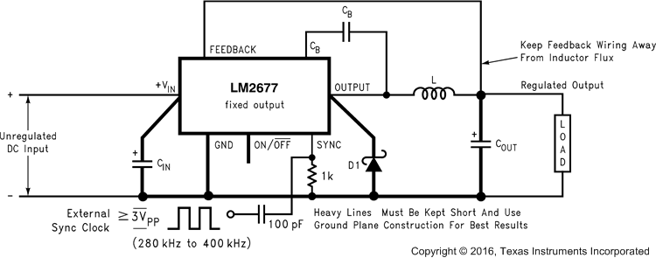
Figure 7. Basic Circuit For Fixed Output Voltage Applications

Design Requirements
Table 6 lists the design requirements for the adjustable output voltage application.
Table 6. Design Parameters
PARAMETER | VALUE
Required output voltage, V_{OUT} | 3.3 V
Maximum DC input voltage, V_{IN_MAX} | 16 V
Maximum output load current, I_{LOAD_MAX} | 2.5 A

Detailed Design Procedure
A system logic power supply bus of 3.3 V is to be generated from a wall adapter which provides an unregulated DC voltage of 13 V to 16 V. The maximum load current is 2.5 A. Through-hole components are preferred.
Step 1: Select an LM2677T, 3.3 V. The output voltage has a tolerance of ±2% at room temperature and ±3% over the full operating temperature range.
Step 2: Use the nomograph for the 3.3 V device, Figure 8. The intersection of the 16-V horizontal line (V_{in} max) and the 2.5-A vertical line (I_{load} max) indicates that L33, a 22-μH inductor, is required. From Table 7, L33 in a through-hole component is available from Renco with part number RL-1283-22-43 or part number PE-53933 from Pulse Engineering.
Table 7. Inductor Manufacturer Part Numbers()
INDUCTOR REF. # | INDUCTANCE (µH) | CURRENT (A) | RENCO |  | PULSE ENGINEERING |  | COILCRAFT
INDUCTOR REF. # | INDUCTANCE (µH) | CURRENT (A) | THROUGH HOLE | SURFACE MOUNT | THROUGH HOLE | SURFACE MOUNT | SURFACE MOUNT
L23 | 33 | 1.35 | RL-5471-7 | RL1500-33 | PE-53823 | PE-53823S | DO3316-333
L24 | 22 | 1.65 | RL-1283-22-43 | RL1500-22 | PE-53824 | PE-53824S | DO3316-223
L25 | 15 | 2.00 | RL-1283-15-43 | RL1500-15 | PE-53825 | PE-53825S | DO3316-153
L29 | 100 | 1.41 | RL-5471-4 | RL-6050-100 | PE-53829 | PE-53829S | DO5022P-104
L30 | 68 | 1.71 | RL-5471-5 | RL6050-68 | PE-53830 | PE-53830S | DO5022P-683
L31 | 47 | 2.06 | RL-5471-6 | RL6050-47 | PE-53831 | PE-53831S | DO5022P-473
L32 | 33 | 2.46 | RL-5471-7 | RL6050-33 | PE-53932 | PE-53932S | DO5022P-333
L33 | 22 | 3.02 | RL-1283-22-43 | RL6050-22 | PE-53933 | PE-53933S | DO5022P-223
L34 | 15 | 3.65 | RL-1283-15-43 | — | PE-53934 | PE-53934S | DO5022P-153
L38 | 68 | 2.97 | RL-5472-2 | — | PE-54038 | PE-54038S | —
L39 | 47 | 3.57 | RL-5472-3 | — | PE-54039 | PE-54039S | —
L40 | 33 | 4.26 | RL-1283-33-43 | — | PE-54040 | PE-54040S | —
L41 | 22 | 5.22 | RL-1283-22-43 | — | PE-54041 | P0841 | —
L44 | 68 | 3.45 | RL-5473-3 | — | PE-54044 | — | —
L45 | 10 | 4.47 | RL-1283-10-43 | — | — | P0845 | DO5022P-103HC
L46 | 15 | 5.60 | RL-1283-15-43 | — | — | P0846 | DO5022P-153HC
L47 | 10 | 5.66 | RL-1283-10-43 | — | — | P0847 | DO5022P-103HC
L48 | 47 | 5.61 | RL-1282-47-43 | — | — | P0848 | —
L49 | 33 | 5.61 | RL-1282-33-43 | — | — | P0849 | —

Step 3: Use Table 8 to determine an output capacitor. With a 3.3-V output and a 22-μH inductor there are four through-hole output capacitor solutions with the number of same type capacitors to be paralleled and an identifying capacitor code given. Table 4 6 provides the actual capacitor characteristics. Any of the following choices works in the circuit:
- 1 × 220-μF, 10-V Sanyo OS-CON (code C5)
- 1 × 1000-μF, 35-V Sanyo MV-GX (code C10)
- 1 × 2200-μF, 10-V Nichicon PL (code C5)
- 1 × 1000-μF, 35-V Panasonic HFQ (code C7)
Table 8. Output Capacitors for Fixed Output Voltage Application()
OUTPUT VOLTAGE (V) | INDUCTANCE (µH) | SURFACE MOUNT
OUTPUT VOLTAGE (V) | INDUCTANCE (µH) | AVX TPS SERIES |  | SPRAGUE 594D SERIES |  | KEMET T495 SERIES
OUTPUT VOLTAGE (V) | INDUCTANCE (µH) | NO.() | C CODE() | NO.⁽2⁾ | C Code⁽2⁾ | NO.⁽2⁾ | C CODE⁽2⁾
3.3 | 10 | 5 | C1 | 5 | C1 | 5 | C2
3.3 | 15 | 4 | C1 | 4 | C1 | 4 | C3
3.3 | 22 | 3 | C2 | 2 | C7 | 3 | C4
3.3 | 33 | 1 | C1 | 2 | C7 | 3 | C4
5 | 10 | 4 | C2 | 4 | C6 | 4 | C4
5 | 15 | 3 | C3 | 2 | C7 | 3 | C5
5 | 22 | 3 | C2 | 2 | C7 | 3 | C4
5 | 33 | 2 | C2 | 2 | C3 | 2 | C4
5 | 47 | 2 | C2 | 1 | C7 | 2 | C4
12 | 10 | 4 | C5 | 3 | C6 | 5 | C9
12 | 15 | 3 | C5 | 2 | C7 | 4 | C9
12 | 22 | 2 | C5 | 2 | C6 | 3 | C8
12 | 33 | 2 | C5 | 1 | C7 | 3 | C8
12 | 47 | 2 | C4 | 1 | C6 | 2 | C8
12 | 68 | 1 | C5 | 1 | C5 | 2 | C7
12 | 100 | 1 | C4 | 1 | C5 | 1 | C8

Step 4: Use Table 6 to select an input capacitor. With 3.3-V output and 22-μH there are three through-hole solutions. These capacitors provide a sufficient voltage rating and an rms current rating greater than 1.25 A (1/2 I_{load} max). Again using Table 4 for specific component characteristics the following choices are suitable:
- 1 × 1000-μF, 63-V Sanyo MV-GX (code C14)
- 1 × 820-μF, 63-V Nichicon PL (code C24)
- 1 × 560-μF, 50-V Panasonic HFQ (code C13)

Application Curves

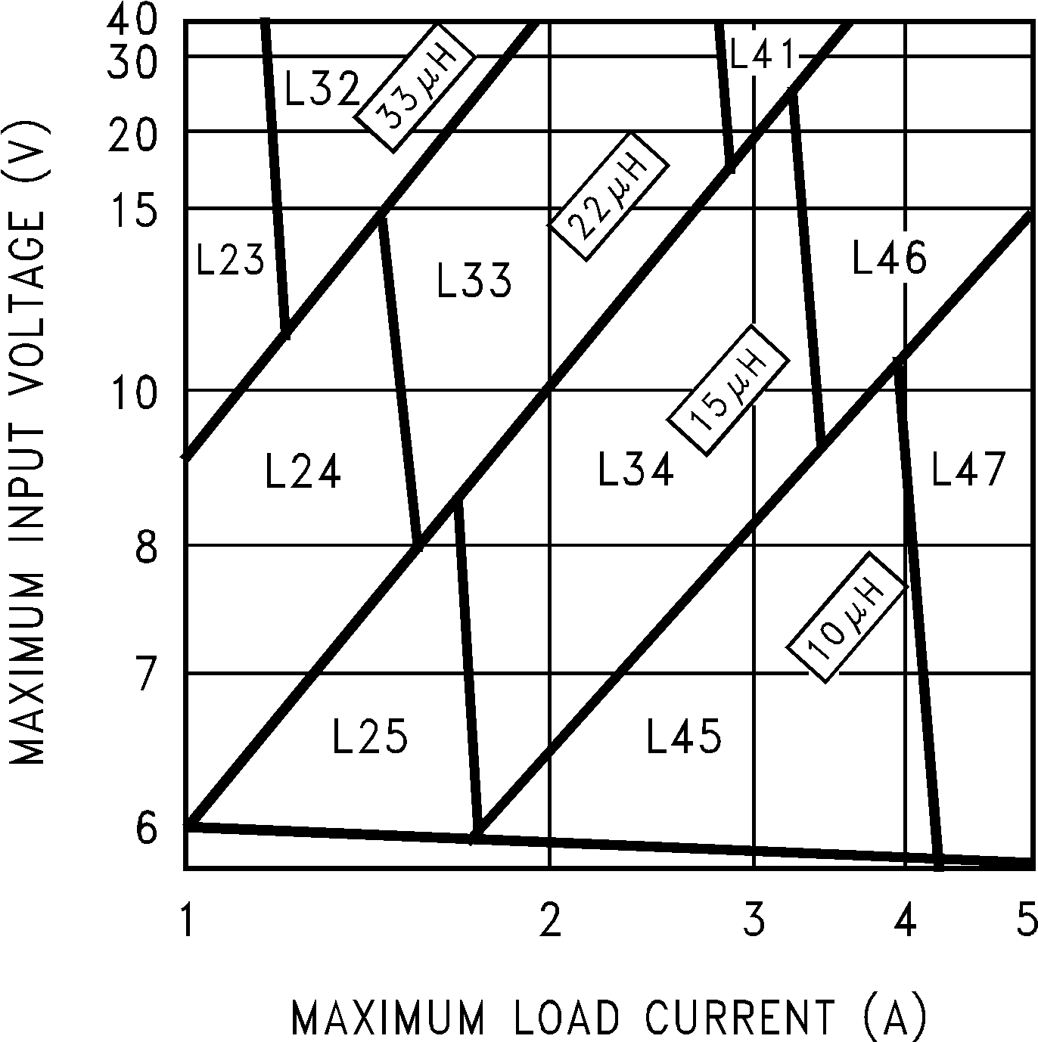
Figure 8. LM2677, 3.3 V
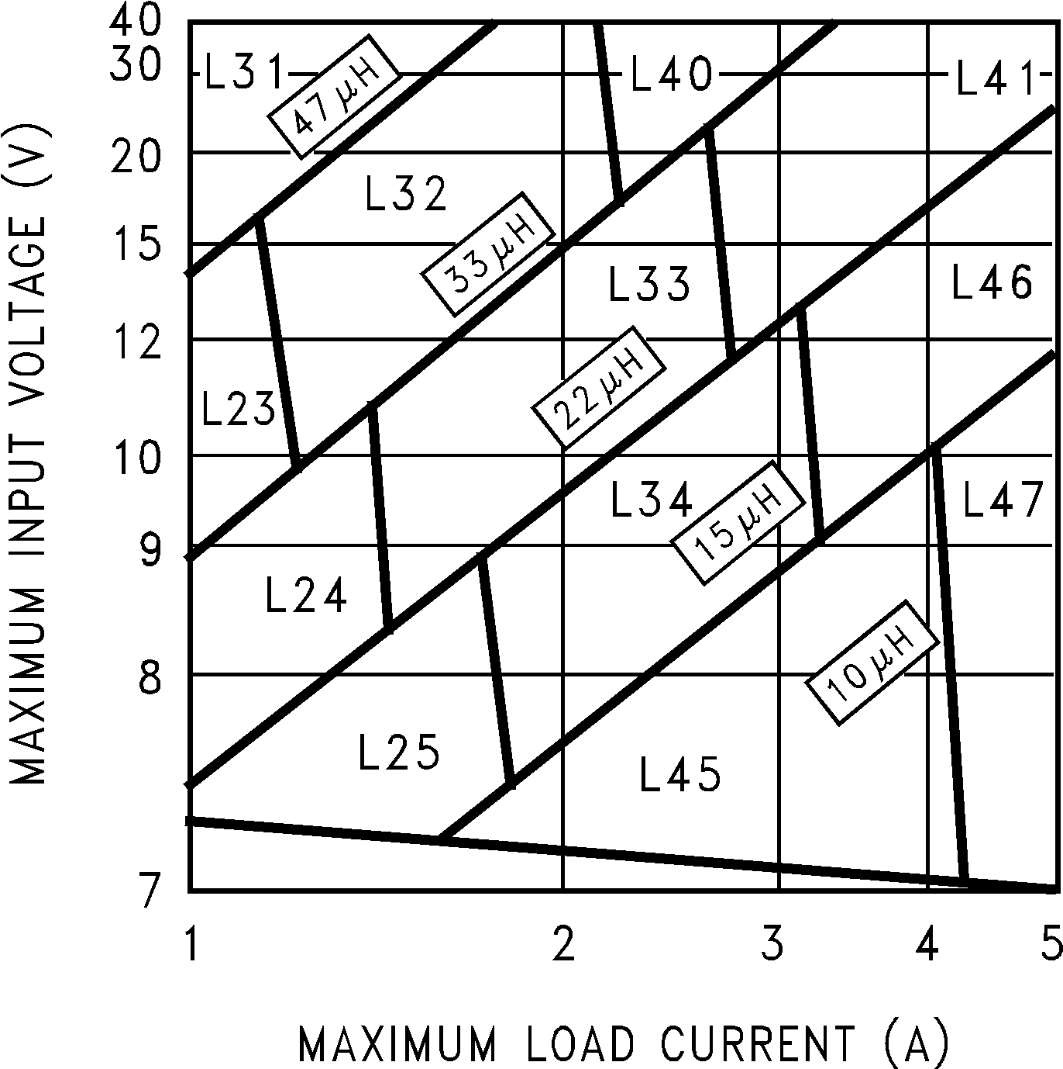
Figure 9. LM2677, 5 V
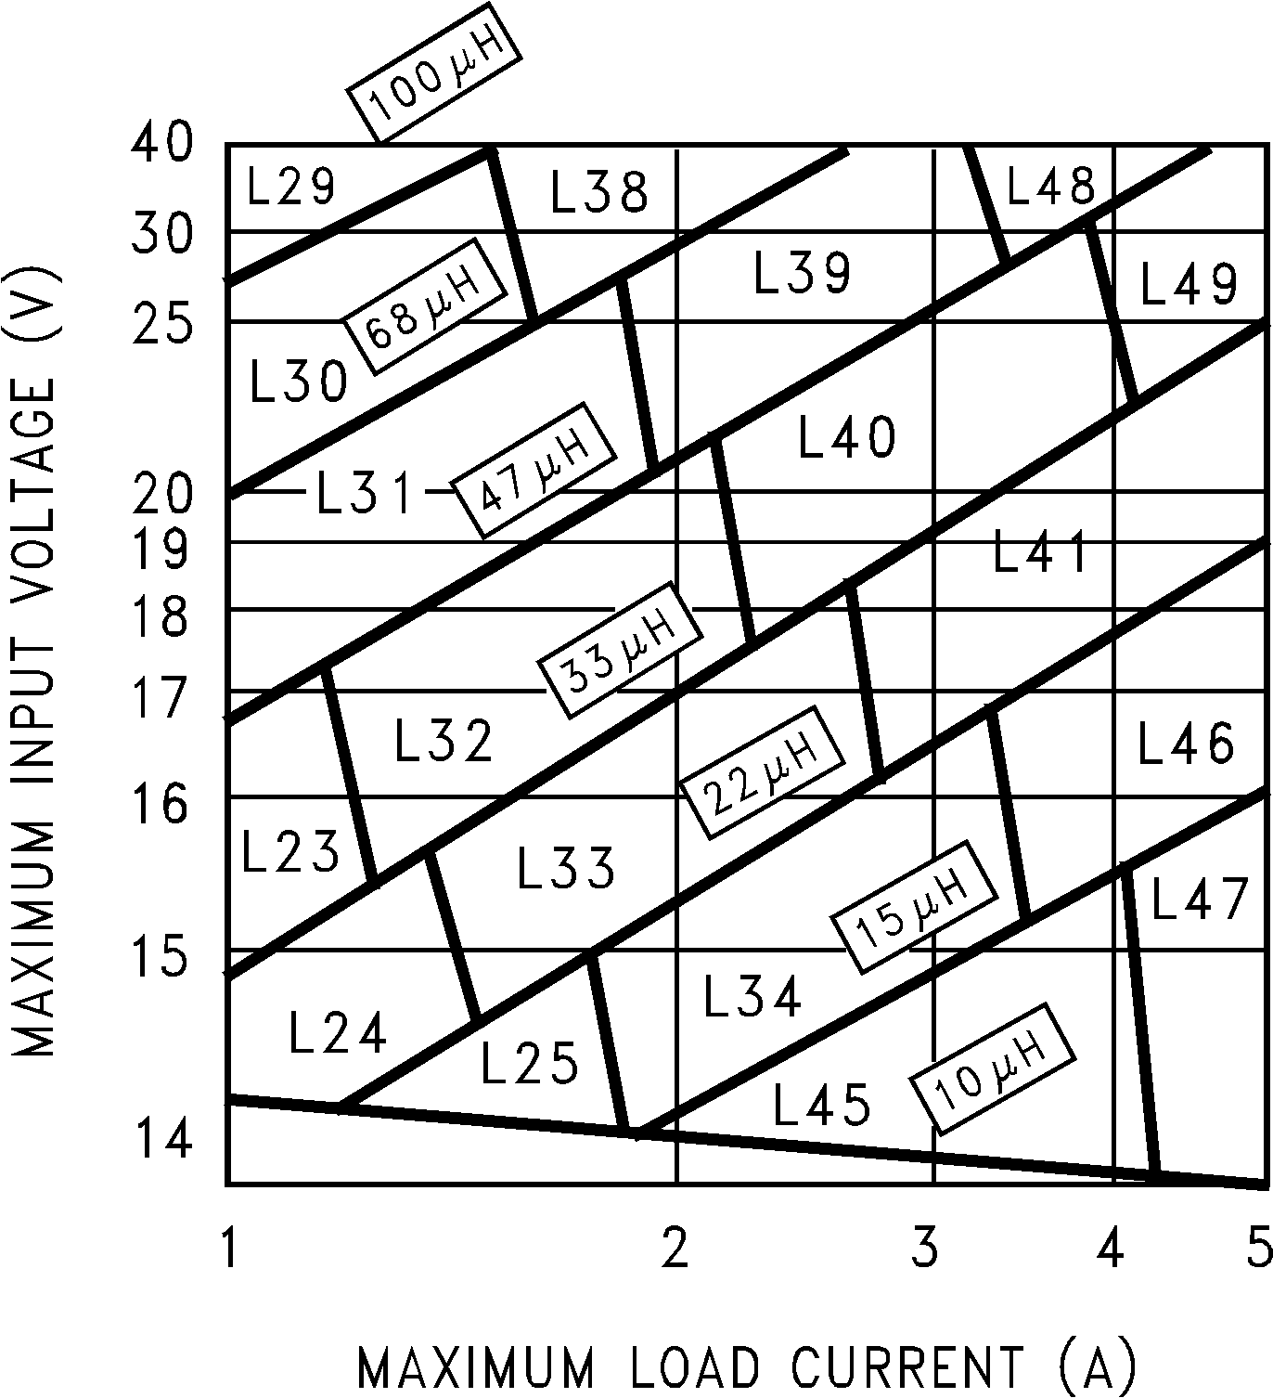
Figure 10. LM2677, 12 V

Adjustable Output Voltage Applications
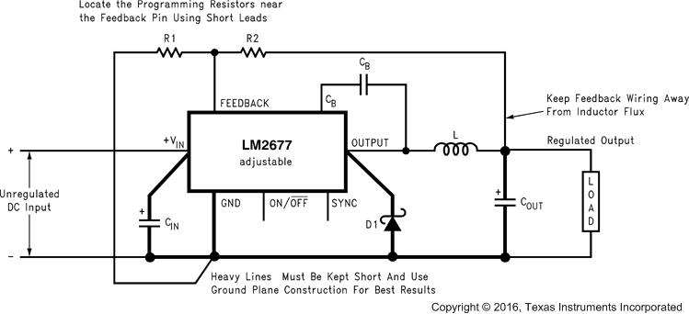
Figure 11. Basic Circuit For Adjustable Output Voltage Applications

Design Requirements
Table 9 lists the design requirements for the adjustable output voltage application.
Table 9. Design Parameters
PARAMETER | VALUE
Required output voltage, V_{OUT} | 14.8 V
Maximum DC input voltage, V_{IN_MAX} | 28 V
Maximum output load current, I_{LOAD_MAX} | 2 A

Detailed Design Procedure
In this example it is desired to convert the voltage from a two-battery automotive power supply (voltage range of 20 V to 28 V, typical in large truck applications) to the 14.8 VDC alternator supply typically used to power electronic equipment from single battery 12-V vehicle systems. The load current required is 2 A maximum. It is also desired to implement the power supply with all surface mount components.
Step 1: Select an LM2677S-ADJ to set the output voltage to 14.9 V that chooses between two required resistors (R1 and R2 in Figure 11). For the adjustable device, the output voltage is set by Equation 1.
Equation 1. 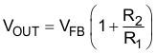
where
V_{FB} is the feedback voltage of typically 1.21 V
A recommended value to use for R1 is 1K. In this example then R2 is determined with Equation 2.
Equation 2. 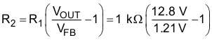
R2 = 11.2 kΩ
The closest standard 1% tolerance value to use is 11.3 kΩ. This sets the nominal output voltage to 14.88 V which is within 0.5% of the target value.
Step 2: To use the nomograph for the adjustable device, Figure 12, requires a calculation of the inductor Volt•microsecond constant (E × T expressed in V × μS) from Equation 3.
Equation 3. 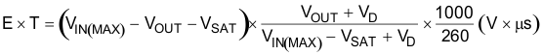
where
V_{SAT} is the voltage drop across the internal power switch which is R_{ds(ON)}times I_{load}
In this example, this would be typically 0.15 Ω × 2 A or 0.3 V and V_{D} is the voltage drop across the forward bisased Schottky diode, typically 0.5 V. The switching frequency of 260 kHz is the nominal value to use to estimate the ON-time of the switch during which energy is stored in the inductor. For this example E × T is found with Equation 4 and Equation 5.
Equation 4. 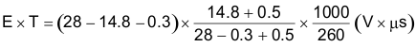
Equation 5. 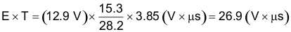
Using Figure 12, the intersection of 27 V × μS horizontally and the 2-A vertical line (I_{load} max) indicates that L38 , a 68-μH inductor, must be used. L38 in a surface mount component is available from Pulse Engineering with part number PE-54038S.
Step 3: Use Table 10 and Table 10 to determine an output capacitor. With a 14.8-V output the 12.5-V to 15-V row is used and with a 68-μH inductor there are three surface mount output capacitor solutions. provides the actual capacitor characteristics based on the C Code number. Any of the following choices can be used:
- 1 × 33-μF, 20-V AVX TPS (code C6)
- 1 × 47-μF, 20-V Sprague 594 (code C8)
- 1 × 47-μF, 20-V Kemet T495 (code C8)
Table 10. Surface-Mount Output Capacitors
OUTPUT VOLTAGE (V) | INDUCTANCE (µH) | AVX TPS SERIES |  | SPRAGUE 594D SERIES |  | KEMET T495 SERIES
OUTPUT VOLTAGE (V) | INDUCTANCE (µH) | NO.() | C CODE() | NO.⁽1⁾ | C CODE⁽1⁾ | NO.⁽1⁾ | C CODE⁽1⁾
1.21 to 2.50 | 33() | 7 | C1 | 6 | C2 | 7 | C3
1.21 to 2.50 | 47⁽3⁾ | 5 | C1 | 4 | C2 | 5 | C3
2.5 to 3.75 | 33⁽3⁾ | 4 | C1 | 3 | C2 | 4 | C3
2.5 to 3.75 | 47⁽3⁾ | 3 | C1 | 2 | C2 | 3 | C3
3.75 to 5 | 22 | 4 | C1 | 3 | C2 | 4 | C3
3.75 to 5 | 33 | 3 | C1 | 2 | C2 | 3 | C3
3.75 to 5 | 47 | 2 | C1 | 2 | C2 | 2 | C3
5 to 6.25 | 22 | 3 | C2 | 1 | C3 | 3 | C4
5 to 6.25 | 33 | 2 | C2 | 2 | C3 | 2 | C4
5 to 6.25 | 47 | 2 | C2 | 2 | C3 | 2 | C4
5 to 6.25 | 68 | 1 | C2 | 1 | C3 | 1 | C4
6.25 to 7.5 | 22 | 3 | C2 | 1 | C4 | 3 | C4
6.25 to 7.5 | 33 | 2 | C2 | 1 | C3 | 2 | C4
6.25 to 7.5 | 47 | 1 | C3 | 1 | C4 | 1 | C6
6.25 to 7.5 | 68 | 1 | C2 | 1 | C3 | 1 | C4
7.5 to 10 | 33 | 2 | C5 | 1 | C6 | 2 | C8
7.5 to 10 | 47 | 1 | C5 | 1 | C6 | 2 | C8
7.5 to 10 | 68 | 1 | C5 | 1 | C6 | 1 | C8
7.5 to 10 | 100 | 1 | C4 | 1 | C5 | 1 | C8
10 to 12.5 | 33 | 1 | C5 | 1 | C6 | 2 | C8
10 to 12.5 | 47 | 1 | C5 | 1 | C6 | 2 | C8
10 to 12.5 | 68 | 1 | C5 | 1 | C6 | 1 | C8
10 to 12.5 | 100 | 1 | C5 | 1 | C6 | 1 | C8
12.5 to 15 | 33 | 1 | C6 | 1 | C8 | 1 | C8
12.5 to 15 | 47 | 1 | C6 | 1 | C8 | 1 | C8
12.5 to 15 | 68 | 1 | C6 | 1 | C8 | 1 | C8
12.5 to 15 | 100 | 1 | C6 | 1 | C8 | 1 | C8
15 to 20 | 33 | 1 | C8 | 1 | C10 | 2 | C10
15 to 20 | 47 | 1 | C8 | 1 | C9 | 2 | C10
15 to 20 | 68 | 1 | C8 | 1 | C9 | 2 | C10
15 to 20 | 100 | 1 | C8 | 1 | C9 | 1 | C10
20 to 30 | 33 | 2 | C9 | 2 | C11 | 2 | C11
20 to 30 | 47 | 1 | C10 | 1 | C12 | 1 | C11
20 to 30 | 68 | 1 | C9 | 1 | C12 | 1 | C11
20 to 30 | 100 | 1 | C9 | 1 | C12 | 1 | C11
30 to 37 | 10 | — | — | 4 | C13 | 8 | C12
30 to 37 | 15 | — | — | 3 | C13 | 5 | C12
30 to 37 | 22 | No values available |  | 2 | C13 | 4 | C12
30 to 37 | 33 |  |  | 1 | C13 | 3 | C12
30 to 37 | 47 | — | — | 1 | C13 | 2 | C12
30 to 37 | 68 | — | — | 1 | C13 | 2 | C12

Application Curve

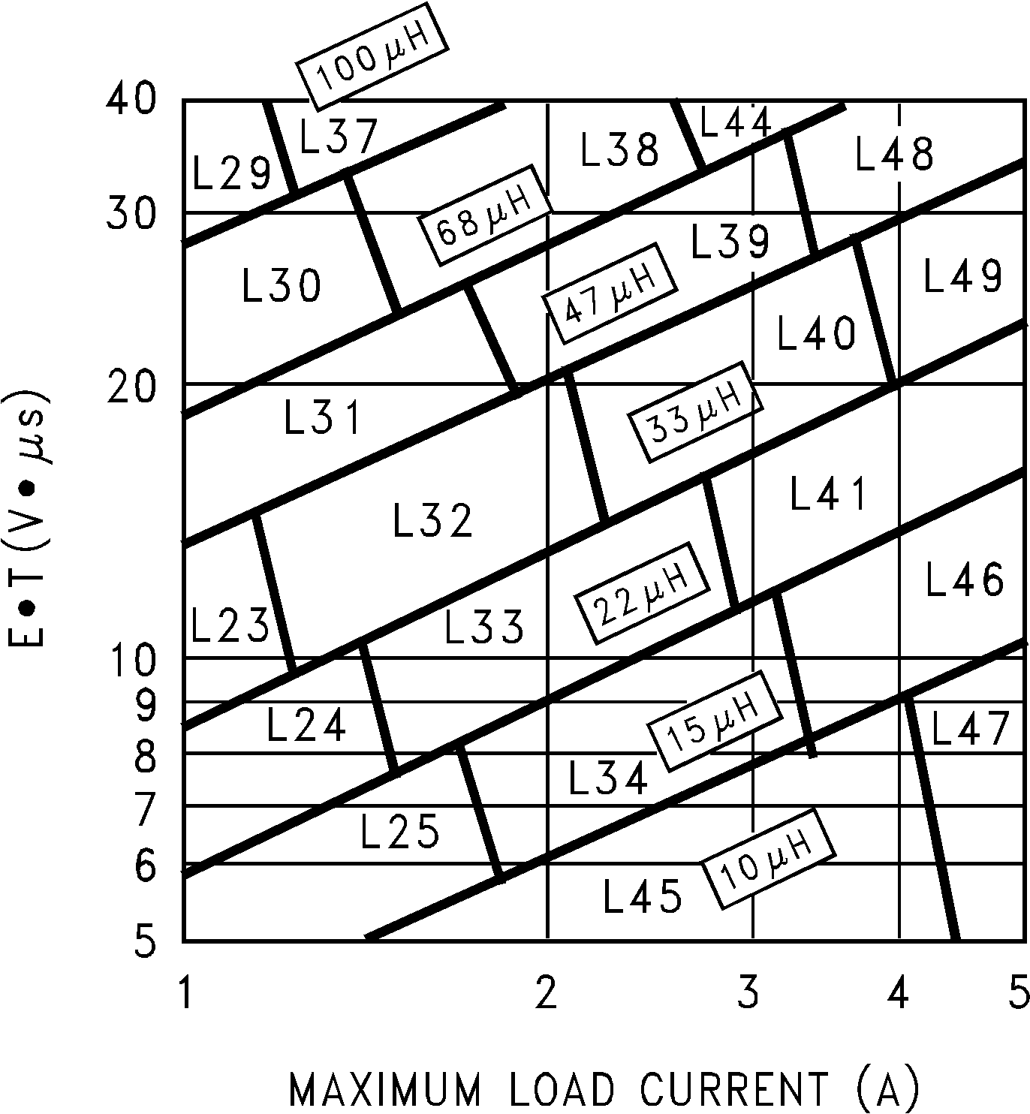
Figure 12. LM2677, Adjustable

Mechanical & Packaging
The following pages include mechanical, packaging, and orderable information. This information is the most current data available for the designated devices. This data is subject to change without notice and revision of this document. For browser-based versions of this data sheet, refer to the left-hand navigation.
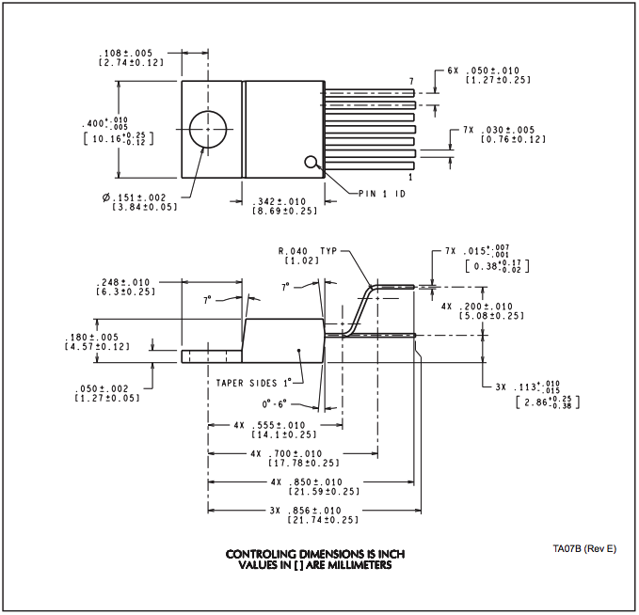
Figure 13. TA07B (Rev E)
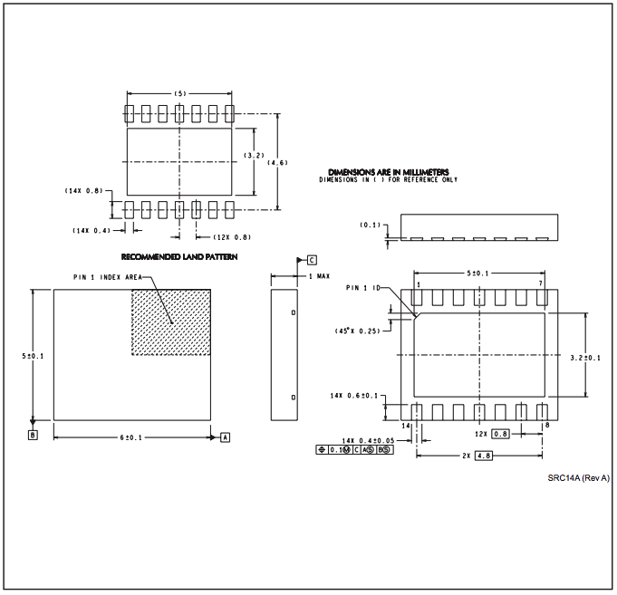
Figure 14. SRC14A (Rev A
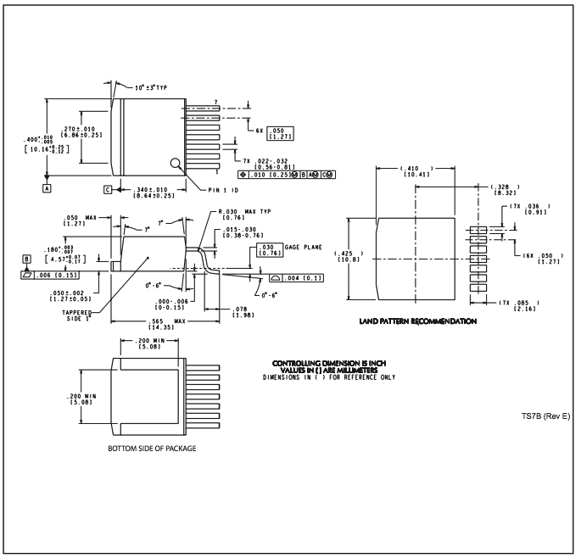
Figure 15. TS7B (Rev E)

Stresses beyond those listed under Absolute Maximum Ratings may cause permanent damage to the device. These are stress ratings only, which do not imply functional operation of the device at these or any other conditions beyond those indicated under Recommended Operating Conditions. Exposure to absolute-maximum-rated conditions for extended periods may affect device reliability.
If Military/Aerospace specified devices are required, please contact the Texas Instruments Sales Office/ Distributors for availability and specifications.
The switch voltage to ground specification applies to DC voltage. An extended negative voltage limit of –10 V applies to a pulse of up to 20 ns, –6 V of 60 ns, and –3 V of up to 100 ns.
JEDEC document JEP155 states that 500-V HBM allows safe manufacturing with a standard ESD control process.
ESD was applied using the human-body model, a 100-pF capacitor discharged through a 1.5-kΩ resistor into each pin.
For more information about traditional and new thermal metrics, see the http://www.ti.com/lit/pdf/spra953 application report.
Junction to ambient thermal resistance for the 7-pin DDPAK/TO-263 mounted horizontally against a PC board area of 0.136 square inches (the same size as the DDPAK/TO-263 package) of 1 oz. (0.0014 in. thick) copper.
Junction to ambient thermal resistance for the 7-pin DDPAK/TO-263 mounted horizontally against a PC board area of 0.4896 square inches (3.6 times the area of the DDPAK/TO-263 package) of 1 oz. (0.0014 in. thick) copper.
Junction to ambient thermal resistance for the 7-pin DDPAK/TO-263 mounted horizontally against a PC board copper area of 1.0064 square inches (7.4 times the area of the DDPAK/TO-263 package) of 1 oz. (0.0014 in. thick) copper. Additional copper area reduces thermal resistance further.
Junction to ambient thermal resistance (no external heat sink) for the 7-pin TO-220 package mounted vertically, with ½ inch leads in a socket, or on a PC board with minimum copper area.
Junction to ambient thermal resistance (no external heat sink) for the 7-pin TO-220 package mounted vertically, with ½ inch leads soldered to a PC board containing approximately 4 square inches of (1 oz.) copper area surrounding the pins.
Junction to ambient thermal resistance for the 14-pin VSON mounted on a PC board copper area equal to the die attach paddle.
Junction to ambient thermal resistance for the 14-lead VSON mounted on a PC board copper area using 12 vias to a second layer of copper equal to die attach paddle. Additional copper area reduces thermal resistance further. For layout recommendations, refer to Application Note, http://www.ti.com/lit/pdf/SNOA401.
Assumes worst case maximum input voltage and load current for a given inductance value
Assumes worst case maximum input voltage and load current for a given inductance value
Assumes worst case maximum input voltage and load current for a given inductance value
Assumes worst case maximum input voltage and load current for a given inductance value
No. represents the number of identical capacitor types to be connected in parallel
C Code indicates the Capacitor Reference number in https://jama.jamasoftware.net/perspective.req?projectIdI&docId06 for identifying the specific component from the manufacturer.
No. represents the number of identical capacitor types to be connected in parallel
C Code indicates the Capacitor Reference number in https://jama.jamasoftware.net/perspective.req?projectIdI&docId06 for identifying the specific component from the manufacturer.
Set to a higher value for a practical design solution.

